**TASK 1-REACTJS**

* **React** (also known as **React.js** or **ReactJS**) is a JavaScript library for building user interfaces. It is maintained by Facebook and a community of individual developers and companies.
* React can be used as a base in the development of [single-page](https://en.wikipedia.org/wiki/Single-page_application) or mobile applications
* **build large applications with data that changes again and again over time**
* 5 major reasons why some of the giants like Facebook, Instagram, and Whatsapp are relying on ReactJs and what’s there for your upcoming project:

### Reactjs is extremely efficient advantages of reactjs

Facebook’s Reactjs creates its own DOM (virtual) where your components live. This approach gives your developer high flexibility and amazing performance gains because React.js calculates what change is needed to be made in the DOM in advance and updates the DOM-trees accordingly. In this way, React.js avoids the costly DOM operations and does updates in an efficient manner.

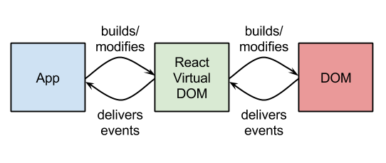

### The JavaScript Library advantages of reactjs

The JSX syntax is a nice and healthy blend of JavaScript and HTML. It is used specifically in ReactJS. JSX simplifies the whole process of writing components for the websites and the HTML aspect allows your developers to render functions without concatenating strings.

The major advantage of ReactJS is, it makes proper use of native APIs and as a result the JavaScript makes the stack work across the platforms.

### It’s awesome for SEO  advanta

One of the major challenges with JavaScript frameworks is, they are not at all search engine friendly. Though there have been some improvements in this area recently, however, that’s not very helpful.

### Focused on User interface advantages

React Native is much more focused on user interface unlike [MeteorJS, Firebase](https://www.valuecoders.com/blog/technology-and-apps/firebase-vs-meteor/) and AngularJs . It gives your users a highly responsive interface with the help of Javascript interactions between the Native environment of the device and React Native. As a result, this increases the application’s load time and helps to keep it running very smoothly without any interruptions.

### It’s easy and out of the box

When you start your project with Facebook’s React.js, don’t forget to install the official chrome extension of React.js. It makes debugging your app much more easier.

After installing the extension, you can have a direct look into the virtual DOM as if you were browsing a regular DOM tree in the element’s panel. Quite amazing!

### Reusable React Components

Another advantage of Facebook’s React js is it offers the ability to reuse code components of a different level anytime. This is a very meaningful time-saving effect. ReactJS components are isolated and change in one doesn’t affect the others. This allows you to reuse components that do not produce changes in and of themselves to make programming more precise, ergonomic, and comfortable for developers.

### Top brands use React js

Right now, React has stepped beyond the walls of Facebook and dozens of renowned businesses have all integrated React into their web applications, including Twitter, the WordPress, New York Times, Airbnb, Yahoo, Netflix, and Uber. [Reactjs development companies](https://www.valuecoders.com/hire-developers/hire-reactjs-developers?utm_source=blog&utm_medium=react-4402&utm_campaign=SMEs" \t "_blank) that use React know how to optimize applications for easy interaction usability.

Surprisingly, React.js stands out , as you are able to run React.js on the server and the virtual DOM will be  returned and rendered to the browser as a regular web page. No need for any other tricks!